**Milestone Four**

Jesenia Roberts

Southern New Hampshire University

CS - 499: Capstone

Professor Goggin

August 4, 2024

**Briefly describe the artifact. What is it? When was it created?**

The chosen artifact was from December of 2023 for the CS-320 Software Testing Automation and Quality Assurance course which assisted in planning, executing, and testing high-quality code. The specific project aimed to create classes that securely contained contact information for users in a map, have the necessary accessor and mutator methods and allow the map to be manipulated as needed. My first enhancement was to port it from Java to Python, both to meet the given requirements and to make the process of adding databases easier.

**Justify the inclusion of the artifact in your ePortfolio. Why did you select this item? What specific components of the artifact showcase your skills and abilities in software development? How was the artifact improved?**

The inclusion of this artifact in the ePortfolio shows the ability to create, manage, and display databases. I chose to enhance this project because I could clearly imagine how a database could be implemented within it. A MongoDB database was added to the project, along with a dashboard for the data to be displayed, added to, and edited in. I utilized the “dash” package from a previous course in the front-end development and was overall able to showcase skill in full-stack development.

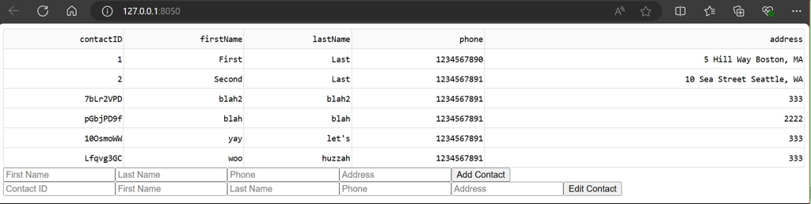

This improves the artifact by adding a place for contacts to be stored, viewed, and edited by administrators, as well as a clear understandable, and functional UI for the user.

**Did you meet the course objectives you planned to meet with this enhancement in Module One? Do you have any updates to your outcome-coverage plans?**

The course objectives were met with this enhancement. A MongoDB database and dashboard were created as was the intended plan during module one. This project met the following course outcome:

*Employ strategies for building collaborative environments that enable diverse audiences to support organizational decision-making in the field of computer science.*

In creating this dashboard, a collaborative environment was created with the intended audience of administrators who work with the contacts, which would support organizational decision-making for the users of the administrative dashboard.

Throughout this process, I have demonstrated the ability to use innovative skills and techniques for implementing database solutions, as shown by the database that was created and its functionality.

I have demonstrated the ability to program solutions to solve problems involving storing, manipulating, or accessing data, as this level of functionality was achieved in this project.

Additionally, I demonstrated the ability to clearly articulate my ideas and accomplishments as indicated by the final project, specifically the dashboard.

**Reflect on the process of enhancing and modifying the artifact. What did you learn as you were creating it and improving it? What challenges did you face?**

There were certainly challenges while making the enhancements, largely with implementing the update methods because the database’s ID required for update calls is not stored in the model layer. As a result, the contact is looked up in the database by the contact ID before updates can be applied. What I gained from this process is a deepened understanding of how to utilize MongoDB as well as creating interfaces that can display its information, a major skill that I learned from this is how to keep UX, model, and database layers in sync.